Name

Mathematics Advanced Year 11
Estimating Change and the Derivative

Book 1 |  | Version: 260825  Feedback:  https://MrDingMaths.com
Contents
Syllabus Content 2
Estimating Change 3
The Derivative of a Linear Function 14
Differentiation by First Principles 15

Syllabus Content
MAV-11-06 interprets the meaning of the derivative and determines the derivative of functions to solve problems
Estimating change
- Define the average rate of change of $y$ with respect to $x$ for a function $y=f\left(x\right)$ over the domain $[a,b]$ as $\frac{Δy}{Δx}=\frac{\text{change in }y}{\text{change in }x}$, that is $\frac{Δy}{Δx}=\frac{f\left(b\right)-f(a)}{b-a}$, and recognise $\frac{f\left(b\right)-f(a)}{b-a}$ as the gradient of the secant through $\left(a,f\left(a\right)\right)$ and $\left(b,f\left(b\right)\right)$ on the graph of $y=f(x)$
- Recognise speed as a rate of change of distance with respect to time
- Use the definition for average rate of change to determine the average speed of an object from a given distance–time graph
- Describe the difference between the average speed of an object and its instantaneous speed
- Determine that the instantaneous speed of an object at time $t$ can be approximated by the average speed between its position at time $t$ and its position some time later, and explain how this approximation can be improved
- Relate the instantaneous speed of an object to the gradient of the tangent at that point on its distance–time graph
- Estimate the instantaneous speed of an object from its distance–time graph
- Recognise when modelling with a linear function that its gradient is the rate of change and determine the rate of change for linear functions in practical situations
- Recognise when modelling with a non-linear function that the rate of change is not constant and is represented by the gradient of the tangent to the curve at each point on the curve
- Estimate the instantaneous rate of change of a non-linear function at a given point from a given graph of a practical situation
The derivative
- Examine the gradient of a curve at a point on the curve using graphing applications
- Approximate the gradient of a curve $f(x)=x^{n}$ at a point $P\left(c,f\left(c\right)\right)$ by considering the gradient of the secant through $P$ and $Q\left(c+h,f\left(c+h\right)\right)$ as the magnitude of $h$ approaches zero, using graphing applications or a spreadsheet
- Infer that $nx^{n-1}$ is the gradient of $f\left(x\right)=x^{n}$ and verify the result using graphing applications
- Define $f'(x)$, for any function $f(x)$ and any value $x$, to be the gradient of the tangent to the curve $y=f(x)$ at the point $P\left(x,f\left(x\right)\right)$ if the tangent exists and is not vertical
- Refer to $f'(x)$ as the derivative of $f(x)$ or the gradient, or derived, function of $f(x)$
- Define differentiation as the process of finding the derivative of a function
- Find derivatives of constant and linear functions
- Define the derivative of the function $f\left(x\right)$ from first principles, as the limiting value of the gradient of the secant $\frac{f\left(x+h\right)-f\left(x\right)}{h}$ as $h$ approaches zero, when this limiting value exists, and use the notation $f'\left(x\right)=\lim_{h→0}\frac{f\left(x+h\right)-f\left(x\right)}{h}$
- Use first principles to find the derivative of quadratic functions

Estimating Change

- Investigation The rate of change of a linear function
Calculus studies change.
Calculus has essential applications in physics, chemistry, medicine, engineering, computing, statistics, business, finance, and economics.
We begin by studying the derivative - a function that describes how another function changes

Imagine the flight of a bumblebee.
Barry makes a beeline from his hive to a nearby flower that is 100 m away.
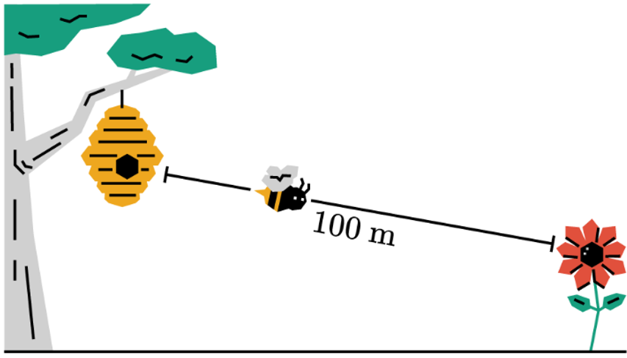

He gets there in 20 seconds by travelling at a constant speed, without accelerating
(no speeding up or slowing down).
What is his speed?
- 5 m/s  - 10 m/s  - 20 m/s | Explanation:  To find speed, we use the formula ……… = ……… ÷ …………

- Investigation The rate of change of a linear function
Let’s look at the same problem using our knowledge of functions.
Since the distance $D$ between Barry and the hive changes depending on time $t$,
we can write distance as a function of time.

$$D(t)$$

Since Barry isn’t accelerating, the graph of this function will be linear (straight line).

At $t=0$ s, Barry is at his hive, so $D\left(0 s\right)=0 m→point (0,0)$

At $t=20$s, Barry is at the flower 100 m away, so $D\left(20\right)=100$ m $→point (20,100)$
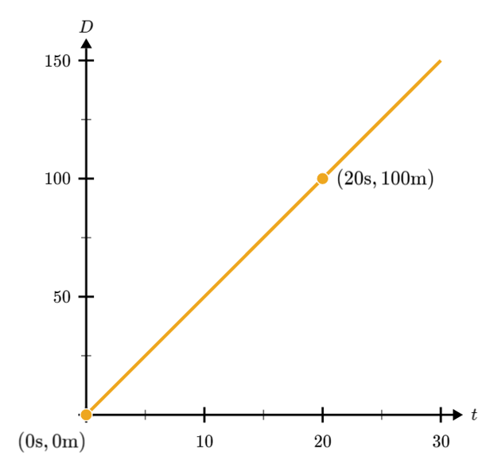

What does the gradient of the line represent?
- Acceleration  - Speed  - Position | The gradient formula is r………… ÷ r……………  In this scenario, it is ………… ÷ …………,  which is the formula for ……………

Important calculus fact:

The rate of change of a linear function is its ……………………

- Key Ideas
- The rate of change of a linear function is its ……………………

- Rate of Change of a Linear Function
The gradient of a linear function is its rate of change.

- Interpret rate of change of linear functions
- The volume of water in a bottle, in mL, after $t$ seconds is given by $v\left(t\right)$, shown below.
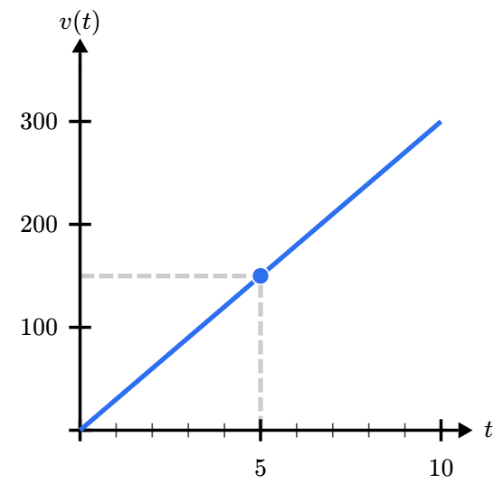
How much water is added to the bottle each second?
a | 20 mL/s
b | 30 mL/s
c | 50 mL/s
d | 60 mL/s

- The function relates distance (m) and time (s).  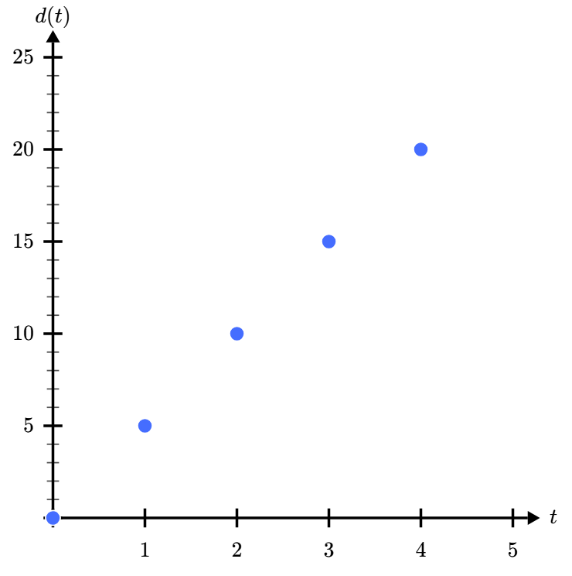  Find the rate of change: …………………  Hence write the equation of the function:  $d\left(t\right)=$ ……… $t+$ …………… | - The function relates velocity (m/s) and time (s)  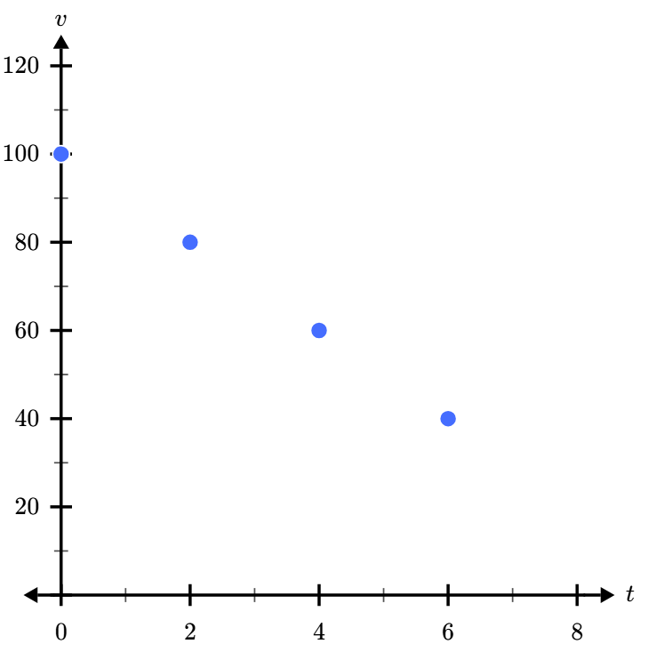  Find the rate of change: …………………  Hence write the equation of the function:  $v\left(t\right)=$ ……… $t+$ ……………

- Investigation The rate of change of a non-linear function
Suppose a hungry bear comes and knocks down the hive.

Objects don’t fall at a constant speed; they accelerate due to gravity.

The function of height against time $h\left(t\right)$ is non-linear (curved)

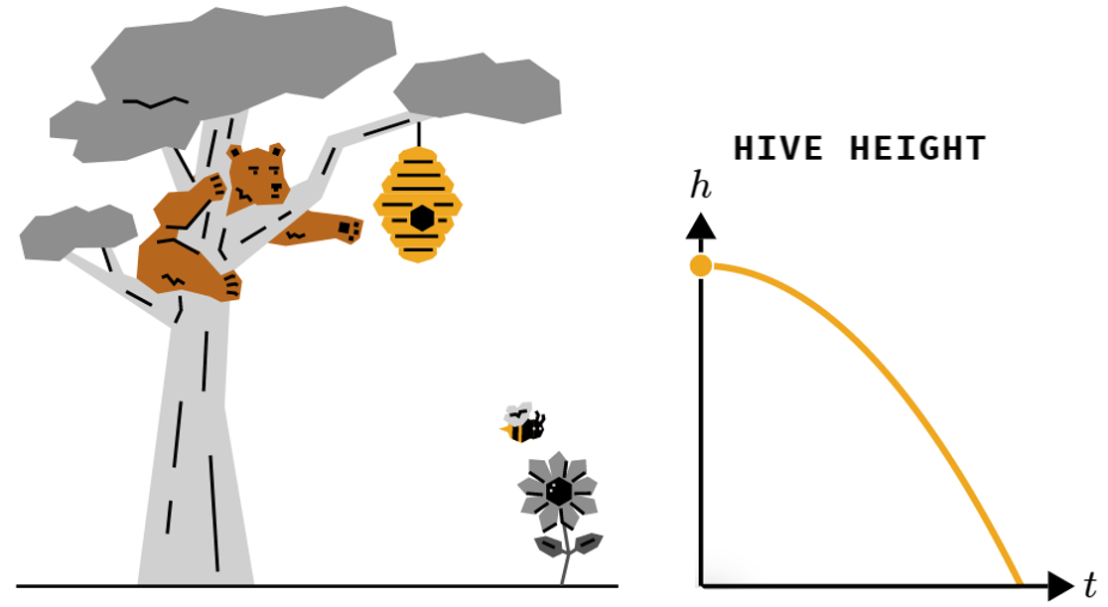
$$2$$
$$20$$

Draw a line between the two endpoints. What is the average speed at which the hive falls?
- 5 m/s  - 10 m/s  - 20 m/s | Average speed = …………… ÷ …………… =

Would it make sense to say that the hive’s speed is 10 at every moment of the fall?
- Yes  - No | The hive ………………… as it falls, it starts slowly and gets faster.  The speed we calculated is the …………… speed, not the speed at every moment.

If the graph of $h(t)$ were linear, then we can find its speed by finding the gradient.

But, since $h(t)$ is non-linear due to acceleration, we can only find the average speed (for now)

- Key Ideas
- The gradient is the …………… …… …………………… of a linear function.
- We can calculate the average rate of change of a non-linear function by constructing a straight line between two points on the function and calculating the …………………… of this line.

- Investigation Secants and tangents
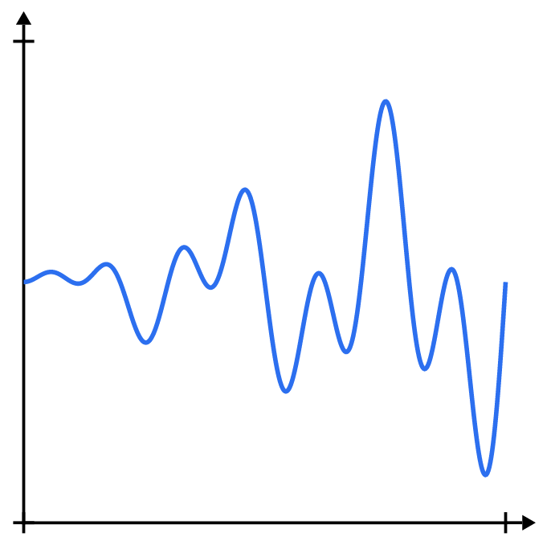
Consider the non-linear function to the right.

We call this function smooth, or continuous.
It doesn’t have sharp corners, holes, or jumps.

For now, continuous means you can draw it with a single stroke of the pen without lifting your hand.

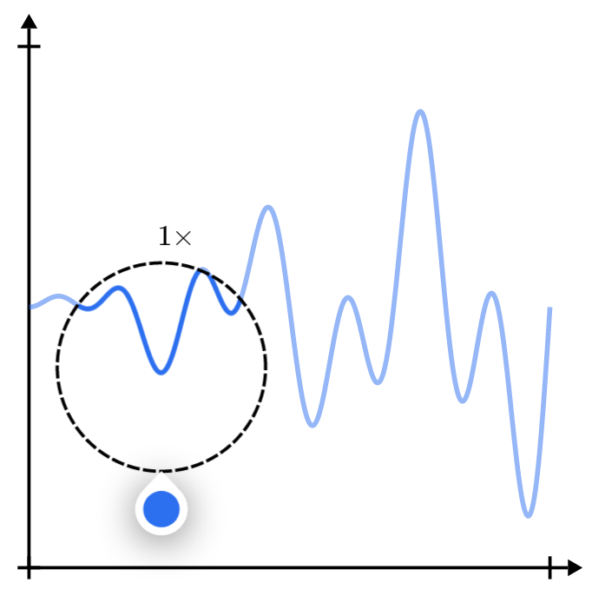
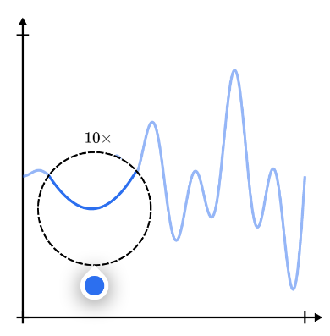
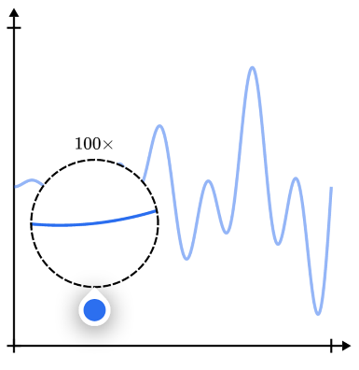
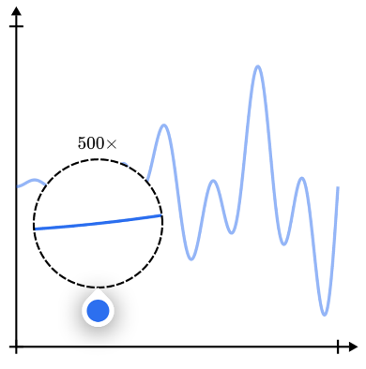
Let’s zoom in on the function.

What do you notice about the function as you zoom in?

When we zoom in far enough to a smooth curve, it looks like a …………… ……………
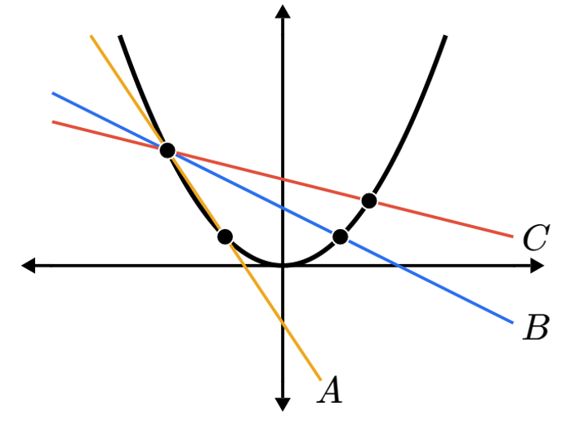
$$(-1,1)$$
Consider the graph of $f\left(x\right)=x^{2}$.
The graph shows three secant lines joining $(-1,1)$
to three points on the parabola.

If we wanted to calculate the gradient,
or rate of change, of the curve at $\left(-1,1\right)$,
which line would be the most accurate?

- A  - B  - C | The ………… two points are on a curve, the more the line passing through them, called the ………………, matches the original curve.

- Key Ideas
- The ………… …… ……………… of a linear function is its gradient.
- We can calculate the ……………… rate of change of a non-linear function by constructing a ……………… ………… between two points on the function and calculating the gradient of this line.
- By choosing two points that are very ……………… to each other, our calculation of the rate of change at that point becomes more ……………………

- Identify Most accurate estimate of rate of change
- Which secant line would be most accurate when finding the rate of change of the function at $x=a$?
a | 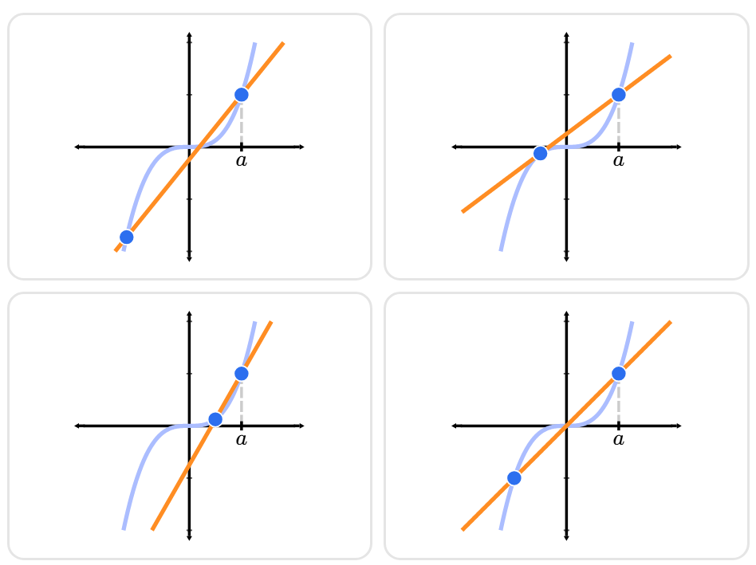 | b |  | c

- Which secant line would be most accurate when finding the rate of change of the function at $x=a$?
a | 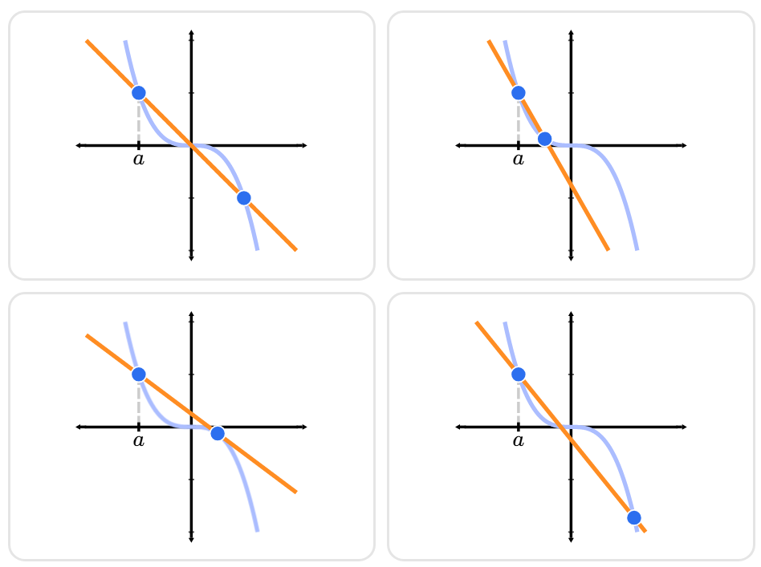 | b |  | c

- What would be the best estimate for the rate of change at $x=-1$?
a |  | b | 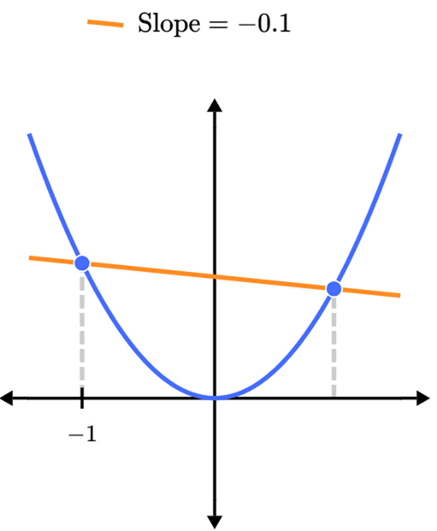 | c | 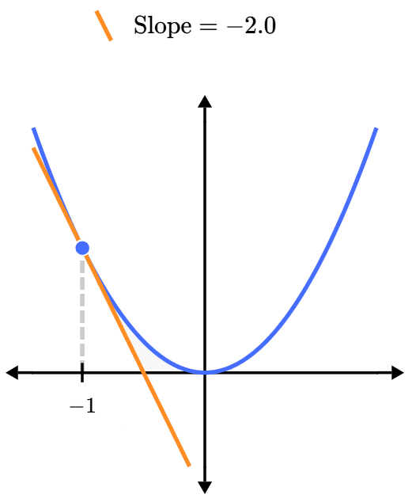  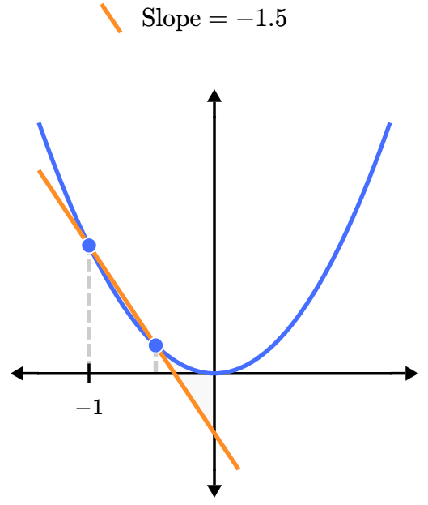

- Summary of Estimating Change
The gradient is the rate of change of a function.
We calculate the average rate of change of a curved function by drawing a secant line between two points on the curve and finding its gradient.
A tangent line to a curve at a point is a straight line that passes through that point and has the exact same slope as the curve at that precise location..
The instantaneous rate of change is the gradient of the tangent.
We call the instantaneous rate of change at a point the derivative.
We write the gradient of the tangent of $f\left(x\right)$ at $x=a$ as $f^{'}\left(a\right)$, read as “$f$ prime $a$.”

Rate of Change of Non-Linear Functions
Secant  Gradient is average rate of change  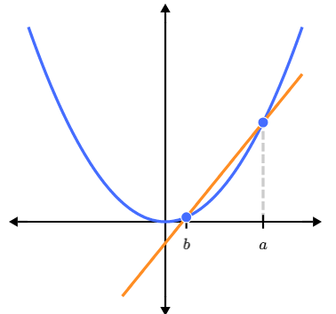 | Tangent  Gradient is instantaneous rate of change  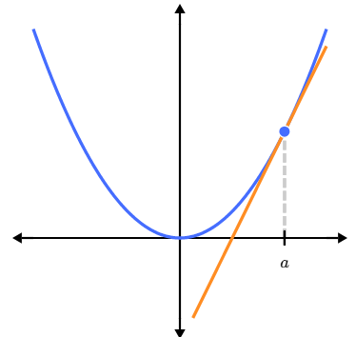

- Interpret Instantaneous rate of change as the gradient of the tangent
- Find the instantaneous rate of change at $x=4$.  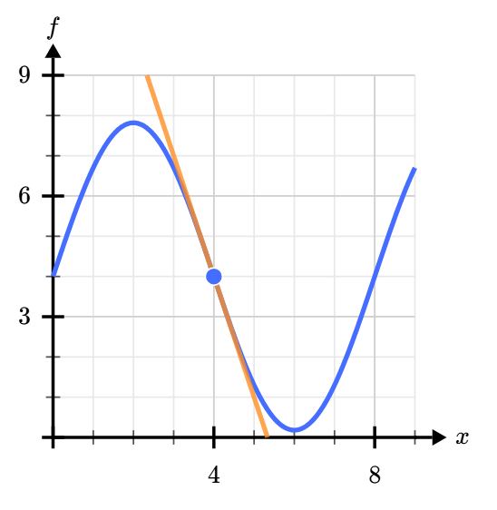  $f^{'}\left(4\right)=$ …………… | 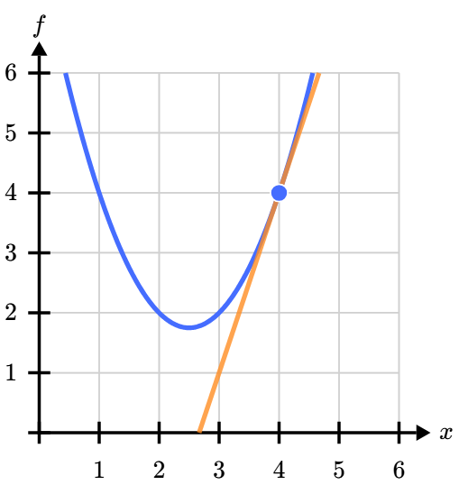  - Find the instantaneous rate of change at $x=4$.  $f^{'}\left(4\right)=$ ……………

Foundation
- The graph of $y=f\left(x\right)$ is shown. Estimate $f^{'}\left(3\right)$.
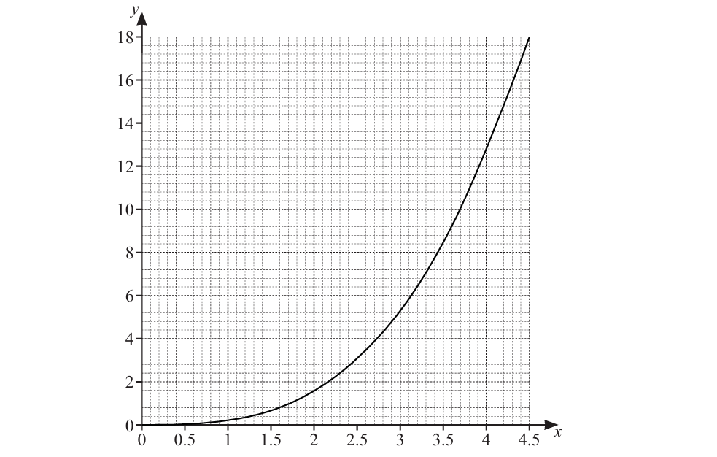

$$f^{'}\left(x\right)≈5$$

- The diagram shows $y=f\left(x\right)$ and the point $P\left(-2,11\right)$.
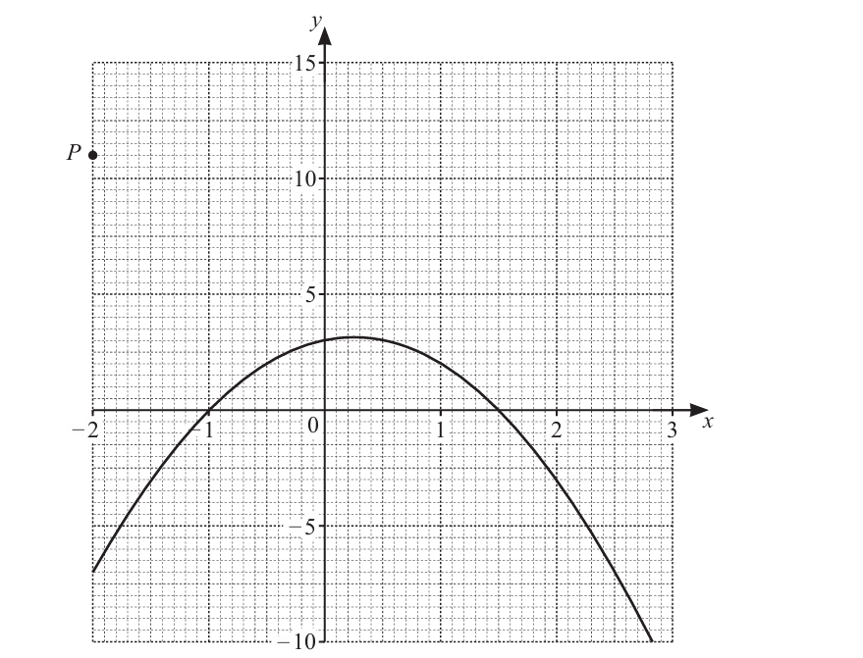

  - The tangent from $P$ touches the graph of $y=f\left(x\right)$ at the point $\left(a,b\right)$.
By drawing this tangent, find the values $a$ and $b$.
$$a=1, b=2$$
  - Find the equation of the tangent in the form $y=mx+c$

$$y=-3x+5$$

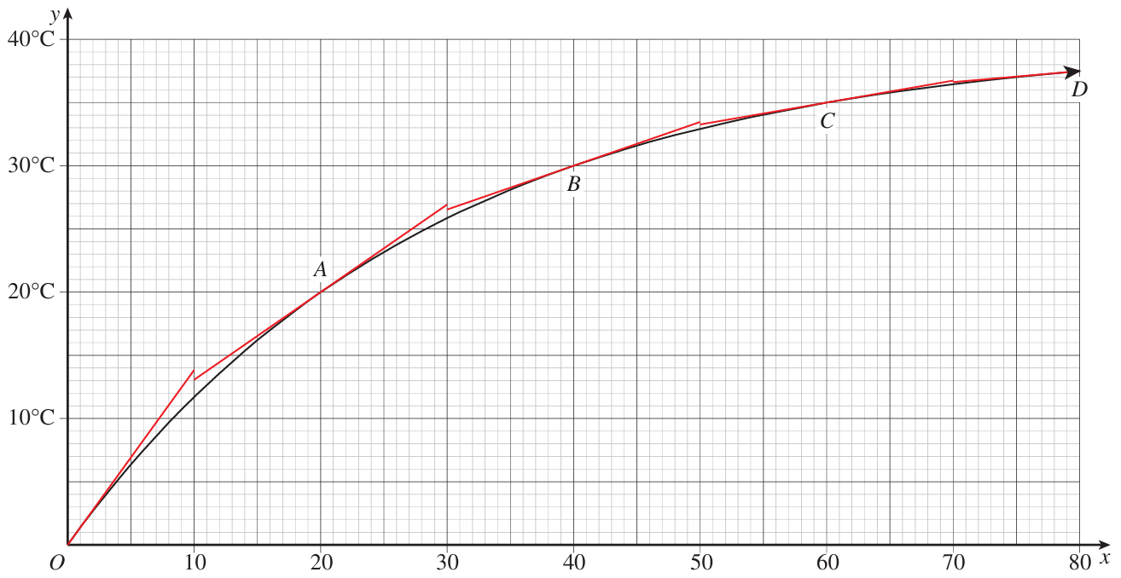
- A bottle of water was taken out of the fridge on a hot day.
Its temperature started at 0°C and started rising.

  - What is the average rate of change of the temperature in the first 20 minutes?

1°C per minute.
  - Is the temperature increasing at this rate the whole time?
Explain how you know by referring to the graph.

No. The graph is not a straight line, so the rate of change is not constant.
If the temperature increased at this rate, then at 80 minutes it would be 80°C, which is not the case.
  - Estimate the instantaneous rate of temperature change at 0 minutes by finding the gradient of the tangent at O. We call this $f^{'}\left(0\right)$.

$$≈1.39°C/min$$
  - Find $f^{'}\left(20\right).$

$$≈0.7°C/min$$
  - Find $f^{'}\left(60\right)$.

$$≈0.2°C/min$$
  - What do you think will happen to the value of $f^{'}\left(x\right)$ as $x→∞$?
Interpret your answer in relation to the context.
The gradient of the tangent will eventually go to zero.
This is because the temperature will stop increasing once the water bottle reaches room temperature.

Development
- We will continue this investigation using Desmos.
- Gradient of Tangent Calculator: https://www.desmos.com/calculator/bae2ab60nl
  - For the graph of $y=x^{2}$, this Desmos applet will calculate the gradient of the tangent, called the derivative, at a given point.
Complete the table of values. You may need to zoom in.
$$x$$ | – 5 | – 4 | – 3 | – 2 | – 1 | 0 | 1 | 2 | 3 | 4 | 5
$$f'\left(x\right)$$ | – 10 | – 8 | – 6 | – 4 | – 2 | 0 | 2 | 4 | 6 | 8 | 10

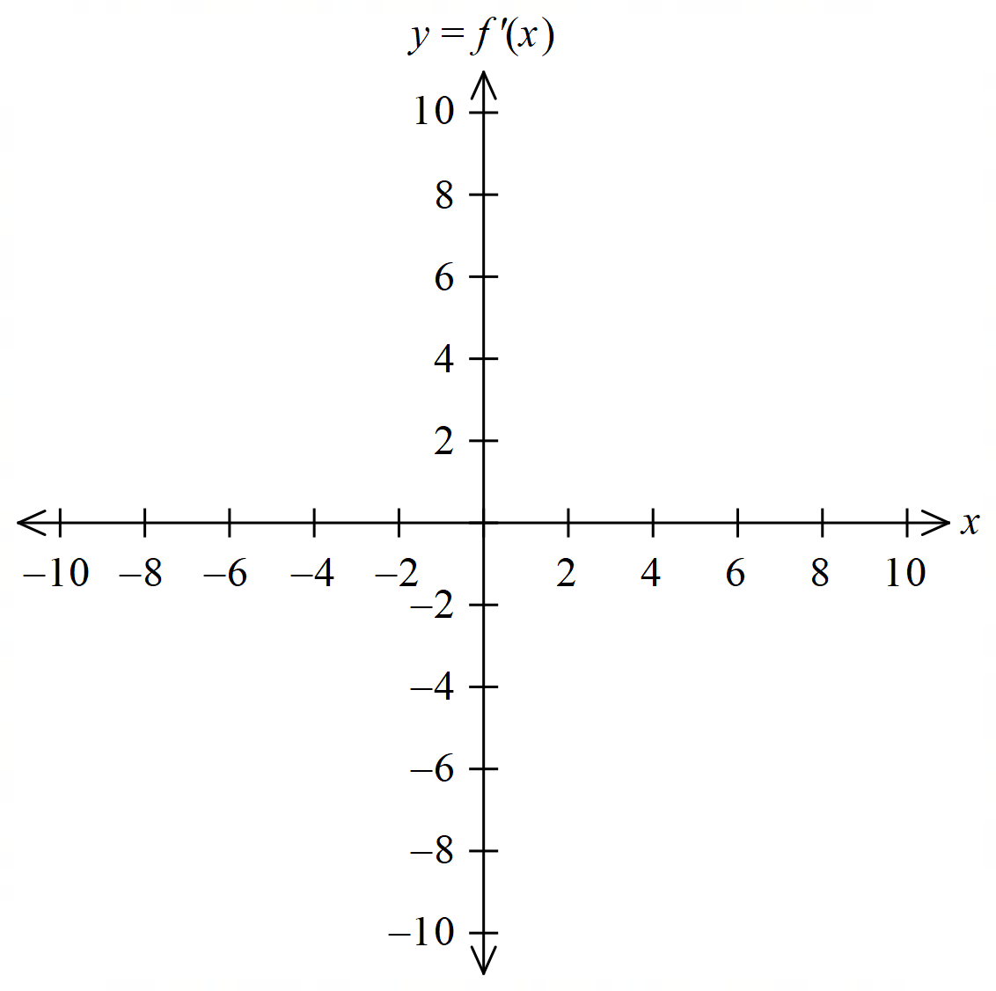
  - Therefore, sketch the graph of $y=f^{'}\left(x\right)$ and determine the equation of $f^{'}\left(x\right)$.

$f'(x) =$ ……………………
$$f^{'}\left(x\right)=2x$$

  - Repeat for $y=x^{3}$. Use the left menu of the Desmos app to change the equation.
$$x$$ | – 4 | – 3 | – 2 | – 1 | 0 | 1 | 2 | 3 | 4
$$f'\left(x\right)$$ | 48 | 27 | 12 | 3 | 0 | 3 | 12 | 27 | 48
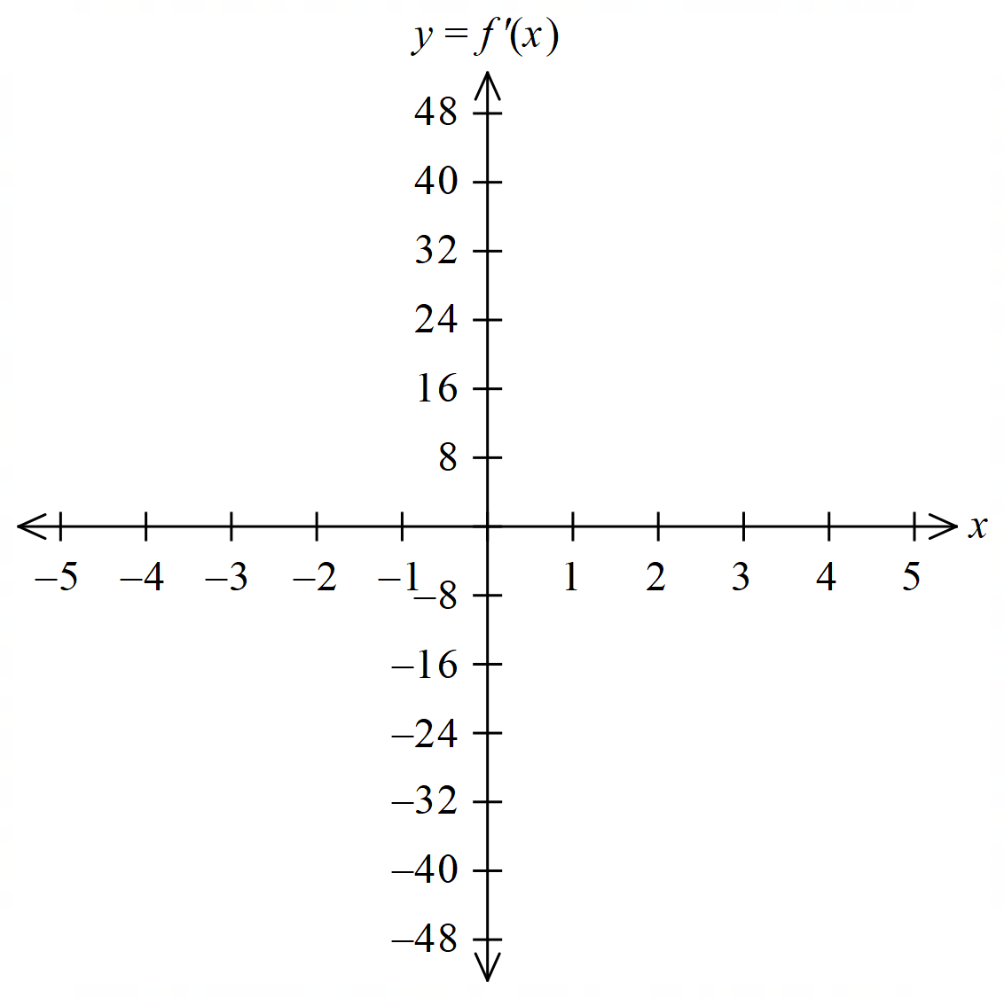

$f'(x) =$ ……………………
$$f^{'}\left(x\right)=3x^{2}$$

- We will continue this investigation using GeoGebra.
- Derivative tracer: https://www.geogebra.org/m/xqmt2tfk
This applet will automatically sketch $f^{'}\left(x\right)$ for given values of $x$.
Use the slider to create the derivative function. SHOW DERIVATIVE will give the equation $f^{'}\left(x\right)$.
Use the RESET SCREEN button between questions.
  - What is the equation of $f^{'}\left(x\right)$ when $f\left(x\right)=x^{2}$?
$$f^{'}\left(x\right)=2x$$
  - What is the equation of $f^{'}\left(x\right)$ when $f\left(x\right)=-x^{2}$?
$$f^{'}\left(x\right)=-2x$$
  - What is the equation of $f^{'}\left(x\right)$ when $f\left(x\right)=3x^{2}$?
$$f^{'}\left(x\right)=6x$$
  - What is the equation of $f^{'}\left(x\right)$ when $f\left(x\right)=3x^{2}+1$?
$$f^{'}\left(x\right)=6x$$
  - What type of graph is the derivative function when $f\left(x\right)$ is quadratic?
Linear.
  - Does the constant term influence the derivative?
Explain your observation by referring to the gradient.
No. The constant term does not affect the derivative.
The constant term shifts the curve vertically, so it does not change the gradient.
  - What is the equation of $f^{'}\left(x\right)$ when $f\left(x\right)=x^{3}$?
$$f^{'}\left(x\right)=3x^{2}$$
  - What is the equation of $f^{'}\left(x\right)$ when $f\left(x\right)=-x^{3}$?
$$f^{'}\left(x\right)=-3x^{2}$$
  - What is the equation of $f^{'}\left(x\right)$ when $f\left(x\right)=2x^{3}-4x^{2}+5x$?
$$f^{'}\left(x\right)=6x^{2}-8x+5$$
  - What type of graph is the derivative function when $f\left(x\right)$ is cubic?
Quadratic, or parabola.
  - Come up with a way to quickly find the derivative function $f^{'}\left(x\right)$ from the equation of $f\left(x\right)$.

For each term, multiply the coefficient by the power, then reduce the power by 1.
  - What is the equation of $f^{'}\left(x\right)$ when $f\left(x\right)=x$
$$f^{'}\left(x\right)=1$$
  - What is the equation of $f^{'}\left(x\right)$ when $f\left(x\right)=3x+5$
$$f^{'}\left(x\right)=3$$
  - What is the equation of $f^{'}\left(x\right)$ when $f\left(x\right)=-3x+5$
$$f^{'}\left(x\right)=-3$$
  - What is the equation of $f^{'}\left(x\right)$ when $f\left(x\right)=x^{4}$?
$$f^{'}\left(x\right)=4x^{3}$$
  - What is the equation of $f^{'}\left(x\right)$ when $f\left(x\right)=\sin{x}$?
$$y=\cos{x}$$

The Derivative of a Linear Function

- The Gradient Function
For a function $y=f(x)$, the derivative function $f'(x)$, also called the gradient function or simply the derivative, gives the gradient of the tangent at $x$.
We can write the derivative as $\frac{dy}{dx}$ or $f^{'}\left(x\right)$ or $y^{'}$
We call the process of finding the derivative differentiation.

- The Derivative of Linear Functions
A linear function has a constant rate of change.
A linear function’s derivative is its gradient.
for $f\left(x\right)=mx+c$
$$f^{'}\left(x\right)=m$$

- Identify the derivative of a linear function
$$f\left(x\right)=3x+5 \\ f^{'}\left(x\right)=3$$ | $$f\left(x\right)=-x+15 \\ f^{'}\left(x\right)=-1$$ | $$f\left(x\right)=7 \\ f^{'}\left(x\right)=0$$
Find $f^{'}\left(x\right)$ for these linear functions.
- $f(x)=2x+3$ | - $f(x)=5-3x$ | - $f\left(x\right)=\frac{x}{2}-7$
- $f(x)=-4$ | - $f(x)=ax+b$ | - $f(x)=\frac{2}{3}\left(x+4\right)$
- $f\left(x\right)=\frac{3-5x}{4}$ | - $f(x)=\frac{5}{2}\left(7-\frac{4x}{3}\right)$ | - $f\left(x\right)=\frac{1}{2}+\frac{1}{3}$

Differentiation by First Principles

- Investigation Differentiation by First Principles
Differentiation is the process of finding the derivative.
We can find the derivative geometrically by sketching graphs and tangents, or algebraically using the method we will develop below.

We will now formally define the derivative function, which describes the “instantaneous” rate of change of another function at a point.

Consider the graph of $y=f(x)$.
Two points on the graph are chosen, $x$ and $(x+h)$, where $h$ is some tiny distance.
Find the gradient of the secant that connects these two points.
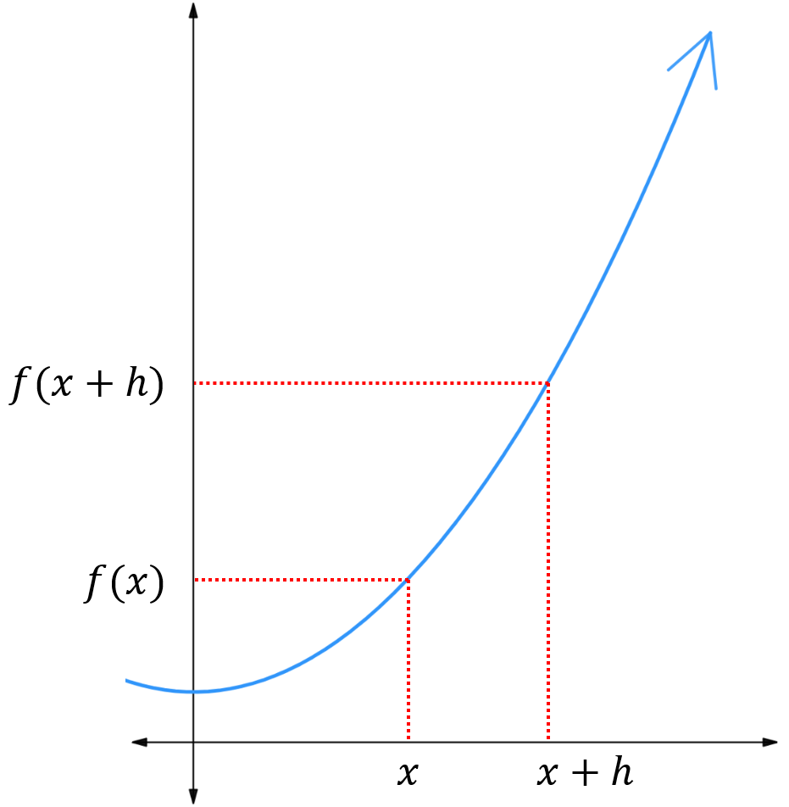

Rise: ……………………………

Run: ……………………………

$m_{secant}$ ……………………………

The gradient of the secant is called the difference quotient.

The derivative $f'(x)$ of a function is the gradient of the tangent (when $h→0)$ at $x$.
$$f^{'}\left(x\right)=m_{tangent}=\lim_{h→0}{\frac{f\left(x+h\right)-f(x)}{h}}$$

The derivative function describes the “instantaneous” rate of change of another function.

- First Principles Differentiation
$$f^{'}\left(x\right)=\lim_{h→0}{\frac{f\left(x+h\right)-f(x)}{h}}$$

- Guided Practice
$f\left(x\right)=x^{2},$use first principles differentiation to show that $f^{'}\left(5\right)=10$  $$f^{'}\left(5\right)=\lim_{h→0}{\frac{f\left(5+h\right)-f\left(5\right)}{h}}$$ | $f\left(x\right)=x^{2},$use first principles differentiation to show that $f^{'}\left(3\right)=6$
$f\left(x\right)=x^{2}+x,$use first principles differentiation to find $f^{'}\left(x\right)$. | $f\left(x\right)=x^{2}-2x$, use first principles differentiation to find $f^{'}\left(x\right)$.

Foundation
$$f^{'}\left(x\right)=\lim_{h→0}{\frac{f\left(x+h\right)-f(x)}{h}}$$
- Consider $f\left(x\right)=5x^{2}$
  - Show that $f\left(1\right)=5$ and $f\left(1+h\right)=5+10h+5h^{2}$.

  - Show that $\frac{f\left(1+h\right)-f(1)}{h}$ $=10+5h$

  - Take the limit as $h→0$ to show that $f^{'}\left(1\right)=10$.

- Consider again $f\left(x\right)=5x^{2}$
  - Show that $f\left(x+h\right)=5x^{2}+10xh+5h^{2}$

  - Show that $\frac{f\left(x+h\right)-f(x)}{h}$ $=10x+5h$

  - Take the limit as $h→0$ to show that $f^{'}\left(x\right)=10x$.

  - Substitute $x=1$ into $f^{'}\left(x\right)$ to confirm $f^{'}\left(1\right)=10$, as found in question 1.

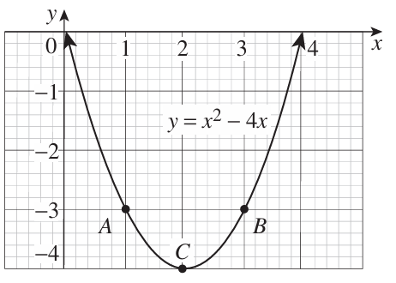
- Consider the function $f\left(x\right)=x^{2}-4x$
  - Show that $\frac{f\left(x+h\right)-f(x)}{h}$ $=2x+h-4$.

  - Show that $f^{'}\left(x\right)=2x-4$ by taking the limit as $h→0$.

  - Evaluate $f^{'}\left(1\right)$ to find the gradient of the tangent to the curve at $A\left(1,-3\right)$.

$$f^{'}\left(1\right)=-2$$
  - Similarly, find the gradients of the tangents at $B\left(3,-3\right)$ and $C\left(2,-4\right)$.

$$f^{'}\left(3\right)=2$$
$$f^{'}\left(2\right)=0$$
  - Check the reasonableness of your answers in parts b, c, d, by sketching a tangent to the curve at those points and inspecting the gradient.

- $f\left(x\right)=mx+c$
  - Use first principles differentiation to find $f^{'}\left(x\right)$.

$$m$$
  - Interpret your answer.

The rate of change of a linear graph is its gradient $m$.
- $f\left(x\right)=c$
  - Use first principles differentiation to find $f^{'}\left(x\right)$.

0
  - Interpret your answer.

The rate of change of a horizontal line is 0.

- Use first principles differentiation to find the derivative function $f^{'}\left(x\right)$ for $x^{2}+10$.

$$2x$$
- Use first principles differentiation to find the derivative function $f^{'}\left(x\right)$ for $2x^{2}-20x$.

$$4x-20$$
- Use first principles differentiation to find the derivative function $f^{'}\left(x\right)$ for $9-4x^{2}$.

$$-8x$$

- HSC Advanced Sample Question Band 4
Use differentiation by first principles to find $y'$ given $y=$ $\frac{5}{x}$.

$$\lim_{h→0}{\frac{\left(\frac{5}{x+h}-\frac{5}{x}\right)}{h}}$$
$$=\lim_{h→0}{ \frac{\left(\frac{5x-5x-5h}{x\left(x+h\right)}\right)}{h}}$$
$$=\lim_{h→0}{ \frac{-5h}{x\left(x+h\right)}×\frac{1}{h}}$$
$$=\lim_{h→0} \frac{-5}{x\left(x+h\right)}$$
$$=-\frac{5}{x^{2}}$$

